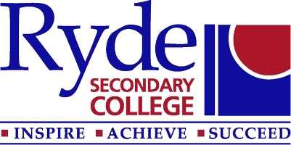

School Community Charter
At Ryde Secondary College and as a public school we are promoting the new NSW Government School Community Charter. This document outlines the responsibilities of all stakeholders in contributing to learning environments that are collaborative, supportive, cohesive and respectful.

In supporting the development of this collaborative, supportive and respectful culture, it is both helpful and respectful to clearly define the boundaries of issues that are increasingly contributing to misunderstandings and damaged relationships.

What is acceptable in the area of Communication?

What is acceptable | What is not acceptable
Having a concern and contacting the school to discuss the problem with the class teacher | Coming to the school office or the classroom and demanding to talk to someone straight away
Making a time to talk through an issue with a staff member when you are calm and in effective control. | Yelling at, threatening or abusing any staff member, either over the phone or in person.
Talking calmly and respectfully to staff | Swearing at any staff member in any situation, at any school event
Use of social media to contact the school respectfully | Making public negative or defamatory comments on social media
Contacting a staff member of the school via the school contact number or email | Contacting staff members regarding a school issue directly through either their personal mobile number or direct email unless you have been specifically invited to, sending overly frequent emails which are derogatory, or threatening and/or require constant responses
Making an appointment with the Principal, Deputy Principal, Year Advisor, Learning and Support Teacher or Head Teacher to discuss an issue and reporting to the front office prior to entering office areas | Coming to the school and bypassing the office to enter one of the office areas.

All staff are governed by a Code of Conduct which is revised annually. We are all human, are imperfect and at times lack the ability to draw on our most effective behaviours, however, what we need to collectively remember is that we are all working together to achieve the very best outcomes for your children. This is done most effectively through clear boundaries, respectful communication and interaction. When issues do occur, having these clear boundaries assists all individuals to reflect, work out what went wrong and plan for more productive interactions in the future. This is what we expect of our children and as their role models, there is no better way for us to lead the way. Working collaboratively and respectfully also ensures continued positive relationships and a shared focus on priorities and effective student learning.

