Ryde Secondary College - School Behaviour Support and Management Plan
Ryde Secondary College is committed to explicitly teaching and modelling positive behaviour and to supporting all students to be engaged with their learning.
Our behaviour support plan enables the College community to meet the personal, social and learning needs of students and enhance their wellbeing in order to foster positive behaviour and engagement in learning.

At Ryde Secondary College, a wide range of practices, structures and strategies are implemented to promote and support student wellbeing. Some are listed below. Students who participate extensively in school life tend to have more positive experiences at school and are more constructive in their behaviour.

- RIOT program
- RAISE mentoring
- Excursions
- Drama Presentations
- Debating competitions
- Public speaking competitions
- Whole school projects
- Student Representative Council
- Mentor programs
- Merit program
- Video Club
- Work experience
- Charity collections
- Bounce back Program
- Empower Program
- Integration Program
- Year focus Days
- Year, Prefect, Music, Drama Camps
- Music Workshops
- Politics Club
- College String Ensemble
- College Concert Band
- College Jazz Band
- College Vocal Ensemble
- Drama Club
- College Choir
- Rock Band
- College Guitar Ensembles
- Duke of Edinburgh Award
- Transition Program
- Sport: grade, recreation, knockouts, carnivals (swimming & athletics), CHS
- College Assemblies
- Student Progress Reports
- Visiting speakers and programs
- TVET courses
- Subject choice evenings
- Parent/student seminars
- Student Progress Interview Evenings
- Orientation Days
- Study Skills Centre (W, Th)
- SRE
- Competitions – Science, Mathematics, Computing, English, Geography
- Education Week activities
- Parents & Citizens Association
- Student Assistance Scheme
- Café Malvina
- P&C Scholarships
- Peer Tutoring
- Debating and public speaking
- Targeted behaviour and/or learning and support
- Careers support

Promoting positive student behaviour and school-wide expectations
Ryde Secondary College has the following school-wide rules and expectations.
- Safe, respectful and orderly classrooms are essential to high quality educational experiences.
An effective learning environment is one where students strive to achieve their best, the rights of all members in the community of learners are valued, all students have the right to learn, teachers the right to teach, and parents support our College Behaviour Policy. While meeting these expectations, students also have the right to expect courtesy, fairness, respect and high-quality teaching.

“An important part of managing the classroom learning environment is establishing and maintaining order, and proactive teachers ensure that off-task behaviour is re-directed before it leads to misbehaviour. Students are focused on instructional tasks and are not misbehaving in an orderly classroom.” Teacher Standards and Accreditation, NSW Department of Education 2022.

- Students are engaged when teachers focus on building academic, sporting, and cultural potential.
Teachers strive to deliver differentiated and quality teaching to foster high quality learning and achievement. They work with students and families to enhance learning, develop students’ talents and skills, as well as supporting students with learning and wellbeing needs.

- Participation in co-curricular activities develops talents, improves student wellbeing, engagement, and behaviour.
It also builds perseverance, teamwork and leadership skills. Students are expected to participate in school life to develop their skills and abilities and wellbeing.

- Student learning is maximized when students support a positive, respectful, and supportive environment.
Students are expected to behave in a respectful, safe and responsible manner, show care for others, in the playground, classroom, when online, and in public places when in uniform, on buses, or involved in school activities.

- Student achievement is enhanced when parents support a positive learning environment and regular school attendance.
When parents enrol their children at Ryde Secondary College, they enter into a partnership with the College staff. This partnership is based on shared responsibility, mutual respect, and an acknowledgement that regular attendance and positive behaviour underpins effective learning.

- Students develop self-esteem and responsibility, by taking pride in their uniform, being punctual, and bringing equipment needed.
When students participate positively in school life and show pride in the college by wearing uniform regularly and appropriately, school spirit and a sense of belonging is enhanced. When they attend school on time, manage their uniform, bring appropriate equipment and resources to school, they demonstrate self-management skills needed for adulthood and the workplace.

The College Values
Ryde Secondary College is committed to providing a high-quality comprehensive education in a caring and supportive environment that promotes and fosters the values of Resilience, Respect and Responsibility. At Ryde Secondary College we believe in:

RESILIENCE
- Empowerment of the individual through learning
- Everyone’s potential to achieve personal excellence through growth and perseverance
- Creating challenging opportunities for students to experience success

RESPECT
- Mutual respect and co-operation
- Tolerance, harmony, and a fair go for all
- Valuing individual differences
- Valuing kindness and showing compassion
- Peaceful resolution of conflict

RESPONSIBILITY
- Active participation of individuals and groups
- Learning in a safe and happy environment
- The individual accepting responsibility for their own actions
- Understanding our responsibility to support the learning and wellbeing of others

Prevention Strategies - Positive Behaviour for Learning

Ryde Secondary College uses the following strategies and systems to explicitly teach, recognise and
reinforce positive student behaviour and behavioural expectations including:

- Teachers positively interacting with students both inside and outside the classroom
- Teachers providing constructive feedback on learning and seeking feedback from students about learning
- Providing an appropriate and diverse curriculum which meets the needs of each student
- Providing opportunities for students to achieve success
- Establishing a fair and consistent code of behaviour, in which appropriate forms of behaviour are encouraged.
- Improving the self-discipline of students by rewarding good behaviour and explaining the consequences of inappropriate behaviour
- Promoting a safe and secure educational environment
- Maintaining an orderly College and classroom environment conducive to learning and wellbeing
- Encouraging students as role models and mentors
- Providing a range of appropriate wellbeing programs and activities for each stage of learning
- Providing opportunities for “student voice” and participation in school life
- Communicating regularly with parents to build constructive partnerships in learning
- Providing appropriate welfare and learning support staff and programs
- Fostering the development of general knowledge
- Encouraging engagement with the community and the development of citizenship skills
- Providing a merit program which rewards positive behaviour and core values.

Merit Program

Ryde Secondary College’s Merit Program works in accordance with the College Values and Code and aims to:
- Reinforce positive work/behaviour models across the College community, within the classroom and beyond
- Reward those students who continually strive to perform well, those students who achieve personal success, and those students who achieve academically, physically, creatively, or emotionally.

Merit Awards should recognise when a student has demonstrated the College Values:

RESILIENCE
- Recognition of excellent work – for example, a project, writing task, an assignment, class talk, homework, creative work, or sporting performance to name a few
- Recognition of improvement – for example, change in attitude, quality of work, homework, or classwork

RESPONSIBILITY
- Recognition of good citizenship and service to others – for example, involvement in college activities that promote fairness, equity and caring for others.

RESPECT
- Recognition of good citizenship and service to others – for example, involvement in academic, social, sporting, and creative activities that promote the College within the broader community. Being a positive representative of Ryde Secondary College outside the College and online.

RSC Merit Program
Recognising Positive Behaviours

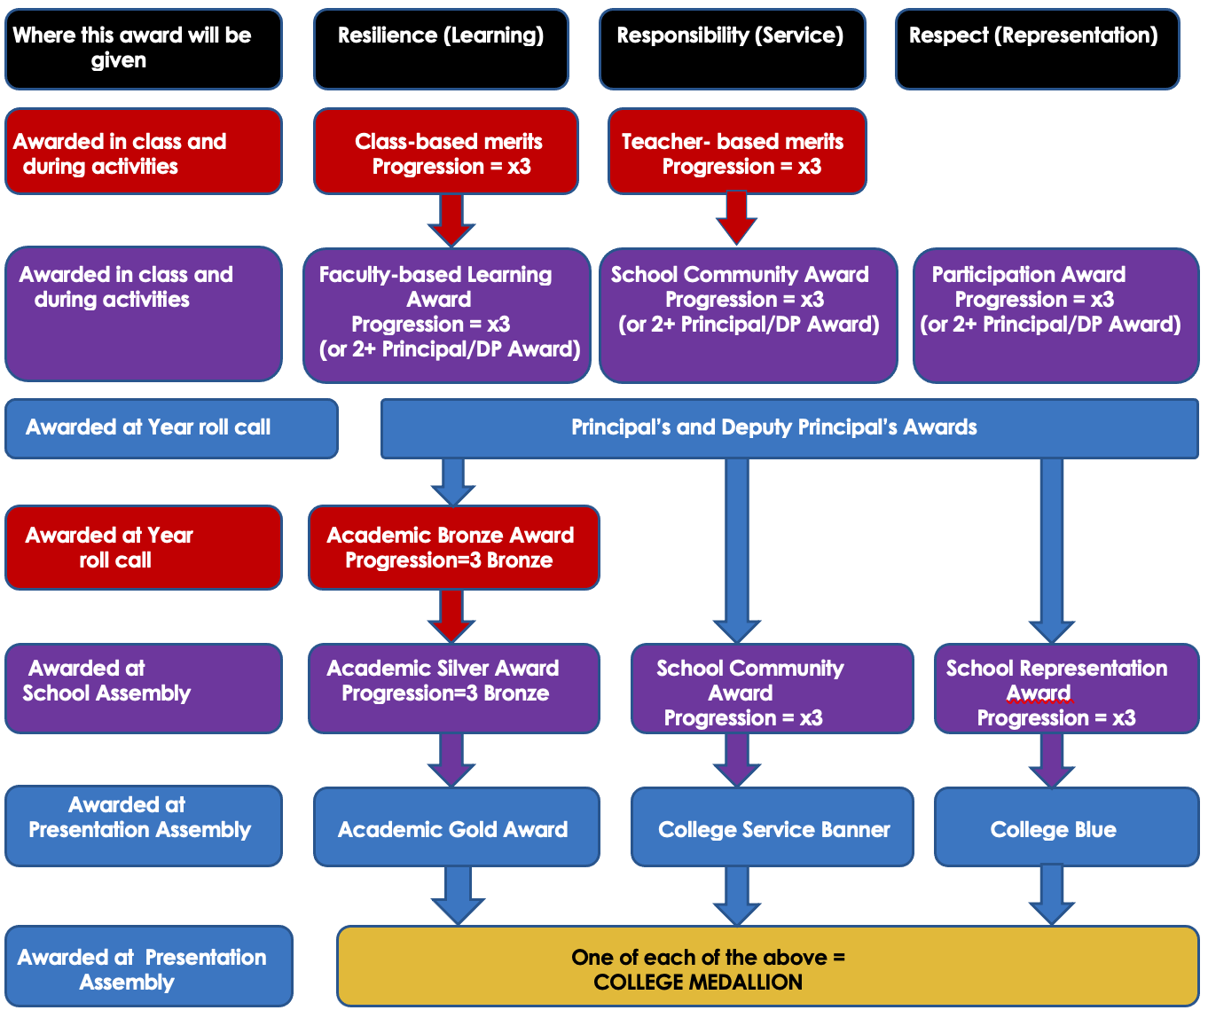

Behaviour code for Ryde Secondary College students

Ryde Secondary College (and all NSW schools and colleges) has the following specific expectations of students for behaviour, to ensure the College is a safe, productive and positive learning environment.

- Sustained application to learning
- Ethical behaviour in all settings including online
- Respect for staff, students, and community members
- Courtesy, care and compassion in all relationships
- Commitment to a safe environment - no violence, discrimination, harassment, bullying or intimidation; no weapons, no illegal drugs, alcohol, vapes or tobacco
- Appropriate use of and access to technology, including laptops, mobile phones
- Peaceful resolution of conflict
- Respectful behaviour in public places, whilst travelling, and online
- Respect for property, including school property and property of others
- Wearing school uniform with pride
- Compliance with the College Behaviour Policy

The expectations and values of Ryde Secondary College are incorporated in this table, covering most situations.
Classrooms
Resilience | Respect | Responsibility
You can demonstrate resilience by:  - taking advantage of opportunities to learn  - continually seeking improvement  - accepting and facing difficulties | You can demonstrate respect by:  - allowing yourself and others to learn  - being on time  - turning off devices when entering the classroom | You can demonstrate responsibility by:  - being proud of your appearance and the College  - looking after your own, others’ and school property  - caring for others
Walkways and Quads
Resilience | Respect | Responsibility
You can demonstrate resilience by:  - being a good sport  - accepting and facing difficulties | You can demonstrate respect by:  - going to class on time  - sharing a safe and clean environment  - allowing a clear thoroughfare | You can demonstrate responsibility by:  - being proud of your appearance and the College  - looking after your own, others’ and school property  - caring for others  - putting rubbish in the bin  - walking carefully and to the left when passing others
Oval
Resilience | Respect | Responsibility
You can demonstrate resilience by:  - being a good sport  - accepting and facing difficulties | You can demonstrate respect by:  - going to class on time  - sharing a safe and clean environment | You can demonstrate responsibility by:  - being proud of your appearance and the College  - looking after your own, others’ and school property  - caring for others  - putting rubbish in the bin  - not playing contact sports
Canteen
Resilience | Respect | Responsibility
You can demonstrate resilience by:  - being a good sport  - accepting and facing difficulties | You can demonstrate respect by:  - going to class on time  - sharing a safe and clean environment | You can demonstrate responsibility by:  - being proud of your appearance and the College  - looking after your own, others’ and school property  - caring for others  - putting rubbish in the bin  - waiting in line for your turn  - playing ball games only during 2nd half of lunch
Uniform
Resilience | Respect | Responsibility
You can demonstrate resilience by:  - keeping a neat appearance  - seeking support when in need | You can demonstrate respect by:  - wearing the correct uniform with pride | You can demonstrate responsibility by:  - keeping your uniform clean and maintained

A Whole School Approach to Student Management

Student Management Program
The major aim of the Student Management Program is to initiate an integrated, systematic approach to student management with a view to fostering reflection and preventing incidents of student misbehaviour or wellbeing issues from becoming entrenched and serious.
A series of staged interventions allows time for a student to reflect upon and adjust their behaviour for the benefit of themselves and their peers. Parent consultation is also undertaken in order to support students in managing issues or behaviours of concern.
The program is designed to provide procedural fairness in the management of students. In this process, documentation necessary to support management of students, is also accumulated.

The Program aims to:
- Reinforce the positive, prevention strategies operating across the College
- Monitor student behaviour and wellbeing across the College
- Provide a means for identifying individual students who require assistance and support prior to a crisis developing
- Provide a range of early, targeted, and intensive interventions to support positive behaviours and learning
- Support the classroom teacher in the areas of student management and wellbeing
- Provide procedural fairness in the management of student behaviour
- Provide a comprehensive record of the behaviour and needs of individual students
- Provide a record of support and interventions undertaken to support individual students including parent consultation as needed
- Allow learning and sustained application for all.

Strategies for dealing with unacceptable behaviour
Most unacceptable behaviour by students can be addressed in the regular classroom or situation.
- Students are advised to discuss any issues with teachers at the end of the lesson or at the earliest opportunity. Some may require counselling, the services of teachers or head teachers, with particular skills, special classes and/or appropriate referral.
- Unacceptable behaviour may also occur in the playground, buses, on excursions, online, and in public places
- Measures and practices may:
    - Assist students towards full participation in the College’s educational program
    - Foster self-reflection and the need for self-regulation
    - Cater for specific learning difficulties
    - Address behavioural problems or wellbeing needs
    - Develop a sense of self-worth and belonging to the College and the wider community.

A range of strategies and programs provide support for positive behaviour and student wellbeing. They include:

Care Continuum | Strategy or Program | Details | Audience
Prevention | Merit Program | A range of awards are provided for students who demonstrate progress, improvement, success, or exemplary behaviour. | School community
Prevention | Student Voice program | A range of opportunities are provided to enable students to provide feedback to teachers and to students, and to raise issues of interest across the school. These include learning logs, Three Way Learning Conversations, Student Leadership and Participation programs eg SRC, Prefects, Year 7 Learning Commission, Tell Them From Me surveys and school surveys. | Whole school, students
Targeted individual support | Helpdesk | Learning Support Helpdesk provided every day via Sentral to encourage students to seek help with their learning | Individual students
Targeted individual learning support | Learning Support program | Students referred by teachers or senior executive for additional support | Individual students or groups of students
Early intervention | Study Center | Support for learning provided two afternoons per week after school for students with expert teachers | Whole school
 | Peer Support Program | Support in regular meetings with Year 10 leaders to foster student engagement and wellbeing | Year 7
Targeted support | Additional Wellbeing Support | Additional funding allocated to enable a teacher to provide daily support for students with specific wellbeing needs. | Whole school student support
Targeted support | Student Services Officer | Full time support for students with wellbeing needs. | Whole school student support
 | RIOT program |  | Whole school student support
Targeted monitoring | Monitoring card | Monitoring cards may be used to allow staff and parents to assess improvement or progress in behaviour or other issues. | Individual student, parents, pre or post suspension
Targeted monitoring | Student management plan, PLP | Plan to manage individual issues or needs, with advice provided to teachers to manage specific issues or needs | Students, parents, staff.
Targeted intervention | Withdrawal from activity, move to other activity | Student may be temporarily or permanently removed/moved from an activity within a class or outside of class, due to health and safety concerns, student wellbeing or health risk. | Student, parents, teachers.
Targeted intervention | Time out- college classroom with teacher or SSO | Time out under supervision of staff member due to mental health, behaviour issues arising. Short duration. | Student, parents, teachers.
Targeted individual intervention | Referral to tutorial center | Referral to centre for suspension or after access request for additional support. Time frame varies. | Student, parents, teachers.
Individual support | RAISE mentoring | Community Mentoring of year 8 students identified by teachers. | Year 8
Individual learning support | Futures Learning, NMS | Targeted individual support with literacy, numeracy, or assessments. | Whole school student support
Individual support | Community Access, Link Support | Community access provided to students with special needs | Support Unit students.
Targeted individual intervention | College service, restitution | May be required following damage to property or other issue where service is best option | Student, parent, Teacher
Targeted individual intervention | May include warning of suspension, suspension, expulsion | Warning of suspension or suspension following significant or persistent behaviour issues. | Student, parent, Teacher

Detention, reflection and restorative practices

Action | When and how long? | Who coordinates? | How are these recorded?
Staff advice to student Year Groups or school as a whole | Roll call, assembly | Year Advisor, HT Year, Deputy Principal, Principal | Not all recorded. Some on Sentral or in newsletter.
Individual teacher interviews with students | After lessons, during recess or lunch | Teacher | Sentral
Head Teacher, Deputy Principal, Principal interviews with students | As needed | Staff member responsible | Sentral
Sport Detention | During sport on Tuesdays | Sport Teacher | Sentral
Whole school Detention | Every lunchtime for half of lunch | Deputy Principals | Sentral
Family consultation and meetings | As needed | Deputy Principals, Principal | Sentral
School Counsellor, Student Advisor, SSO, meetings | As needed | Staff | Sentral or OSCA
Student suspension resolution meetings and post suspension monitoring card, reflection notes if requested, interview with family. | As needed | Deputy Principal/Principal | Post – Suspension form, monitoring card

The Student Management Program often manages issues through a system of stages of intervention and support.

Green Level - Early Intervention | Blue Level – Targeted intervention
A student at this level has become disruptive or behaved in an inappropriate or unacceptable manner in any of the following: the classroom, playground, College activity or during travel between home and the College. The student will be referred to the Head Teacher. The student will be asked to explain their actions and make an acceptable plan to modify his/her behaviour. They will be monitored (within the class or group) and will be required to carry a Faculty Progress Card to monitor this plan. The Head Teacher may withdraw the student from class. The student, if withdrawn from class, will be under the direct supervision of the Head Teacher or a Senior Teacher who will monitor behaviour and progress. The Year Adviser will also assist to improve the behaviour. Parents will be emailed informing them of the student’s placement on Green Level | A student at this level has not appeared to improve his/her behaviour but has continued to disrupt the education of other students or behave in unsatisfactory ways in two or more faculties. The student will be referred to the Head Teacher. The Head Teacher will recommend Blue Level placement to the Student Management Panel. The student will develop, with the Head Teacher Year, a plan to modify his/her behaviour within the classroom and will be required to carry a Daily Progress Card, to be completed by all the student’s teachers, to monitor this plan. Consequences including detention, may apply. The Year Adviser will also assist to improve the behaviour of the student. Parents will be informed by Sentral letter of the student’s placement on Blue Level and be phoned to contribute to the plan for improvement.
Warning of Suspension – Individual intervention | Suspension – Individual intervention
A student at this level has failed to respond to counselling at Blue, or has returned from suspension. The student will receive help from Head Teachers, the Year Adviser, Learning and Support Team, Student Welfare Team and the College Counsellor to improve behaviour. Outside agencies and/or the network Delivery Support team, may be involved. The student will negotiate, with the Deputy Principal, a plan to modify his/her behaviour, and will be required to carry a College Progress Card, to be completed by all of the student’s teachers, to monitor this plan. The student may not be allowed to attend sport or any College excursion or social function. Parents will be informed by a formal caution letter of the student’s placement on Yellow Level and will be consulted via meeting/phone or zoom, to discuss how the behaviour may be improved. A formal warning of suspension will last 50 days. | A student at this level has not improved their behaviour or attitude, nor responded to the assistance provided at Yellow Level, and proved to be beyond the help of the College. A student at this level may also have repeated unacceptable or violent behaviour, or has suddenly demonstrated of gross or persistent misconduct, interference with the safety and wellbeing of others or persistent disruption of learning. The Principal or Deputy Principal will remove the student from all classes and College activities and place them on SUSPENSION to allow time for additional advice and reflection to occur. Parents will be informed and will be required to attend an interview with the Principal or Deputy Principal to resolve the suspension and develop a plan to improve the behaviour.  Suspension allows time for the school to review any behaviour, risk management or learning plans that are in place.  Outside agencies and/or the network Delivery Support team, may be involved.  Expulsion may result following consultation with the Director Public Schools, after repeated suspensions.

Suspension and expulsion from the College

Suspension highlights for the student and the parents the unacceptability of the student’s behaviour, allows time for personal reflection, allows time for the school to review any behaviour, risk management or learning plans that are in place, and enables parents to work with the school to remediate that behaviour.

In most cases the principal will have considered whether possible and appropriate alternative behaviour support measures have been implemented or attempted, and believe that a student’s behaviour/s of concern:
• causes actual harm to ANY person; or
• poses an unacceptable risk to health and safety, learning, and/or the wellbeing of ANY person, including where such a risk is posed by:
- a student’s continuing, consistent, unproductive, and disruptive behaviour that results in a detrimental impact on the educational interests of other students
- all possible interventions and supports to redirect or minimise this behaviour have already been attempted
- a student’s behaviour causes damage to, or the destruction or loss of property.

Actual harm or unacceptable risk to health, safety, learning and/or the wellbeing of ANY person may include the student exhibiting the behaviour/s of concern. Behaviours of concern could include physical violence, verbal abuse or psychological abuse. Other examples may include:
• bullying and cyber-bullying of staff or students
• drugs in schools
• weapons and knives in schools
• assault (including harassment, stalking and intimidation of students and staff at school)
• racism or discrimination, including that based on sex, race, religion, disability, sexual orientation, or gender identity
• misuse of technology (see Technology misuse in schools)
- continual disruption of the learning of others.

The College will work with parents in assisting the student to re-join the College community (which may include counselling, monitoring of progress, and access to special behaviour or support programs.

Expulsion
There are two grounds on which to expel a student from a particular school:
- serious behaviour/s of concern where risk management strategies and interventions, including suspensions, have not been successful
- (Only for students over 17 years of age) unsatisfactory participation in learning, where:
  - a student has received a minimum of two written ‘N’ warnings in the same course from the principal because they are at risk of receiving an ‘N’ determination (non-completion of course requirements for this course); and
  - the unsatisfactory participation in learning has a negative impact on the and learning and/or wellbeing of other students.

  - A principal and Director, Educational Leadership may only expel a student for unsatisfactory participation in learning where a student has received a minimum of two written ‘N’ warnings in the same course from NSW Department of Education, if the principal has:
    - advised the student of the tasks or actions to be undertaken in time for the problem to be corrected and alerted the student to the possible consequences of receiving two written ‘N’ warnings or an ‘N’ determination
    - advised the parent or carer in writing of the initial 'N' warning
    - requested a written acknowledgement of the 'N' warning from the student, parent, or carer
    - issued at least one follow-up 'N' warning letter if the first letter is not effective
    - the student has been given a formal written notice of potential expulsion from the school
    - following the written 'N’ warning letters and notice of potential expulsion, the student has been given the opportunity, time and appropriate support to complete the course requirements but has not done so.

Anti-Bullying and Harassment Plan
All students and staff at Ryde Secondary College have the right to learn, teach and work in a supportive and caring environment that allows everyone the opportunity to reach their potential. This right also carries the responsibility that nothing done, felt, or said interferes with the learning and teaching of others. All members of our school community contribute to preventing bullying by modelling and promoting respectful relationships.

Bullying and harassment in all forms – physical, emotional, verbal, electronic and cyber is viewed as totally unacceptable and against the College Values.

Ryde Secondary College has an extensive student welfare network that aims to provide immediate support for the victims and perpetrators of bullying and harassment. The College aims to do this by:
- providing a comprehensive calendar of wellbeing events and seminars across the year groups that aim to educate students in matters regarding citizenship and dealing with conflict
- thorough investigation of all reported incidents of bullying and harassment
- counselling, support, and mentoring programs for identified victims
- appropriate consequences for perpetrators or bullying and harassment in accordance with the College discipline policy
- counselling, support, and mentoring programs for identified perpetrators with the view to modifying the negative behaviour.

Bullying or Harassment behaviour can be:
- verbal eg name calling, teasing, abuse, putdowns, sarcasm, insults, threats
- physical eg hitting, punching, kicking, scratching, tripping, spitting
- social eg ignoring, excluding, ostracising, alienating, making inappropriate gestures
- psychological eg spreading rumours, dirty looks, hiding or damaging possessions, malicious SMS and email messages, inappropriate use of camera phones

If you find you are the victim of bullying or harassment you can assist the college in addressing the issue by:
- Not retaliating with physical or verbal bullying
- Telling another person, a trusted older student, a parent, a teacher, a Year Adviser, a Deputy Principal, the Principal or College Counsellor, the Student Support Officer.
- Let us know when it starts, don’t let it build up. No one likes bullying; no one deserves bullying; no one needs bullying – let us help you!
- If you see someone else being bullied, tell someone who can help.
- The College’s Anti-Bullying and Harassment Policy can be downloaded from the College website:
https://rydesc-schools.nsw.gov.au

Partnership with parents/carers

Ryde Secondary College partners with parents/carers in establishing expectations for parent engagement in developing and implementing student behaviour management strategies as published in the Student Enrolment Booklet.

Ryde Secondary College communicates these expectations to parents/carers by email, through interviews or meetings, Sentral notices, Facebook, Newsletter, Student Enrolment Booklet, P and C meetings or on documents, as appropriate.

Reviewing dates

Last review date: October 2022

Next review date: Day1 Term 1 2024.

education.nsw.gov.au

